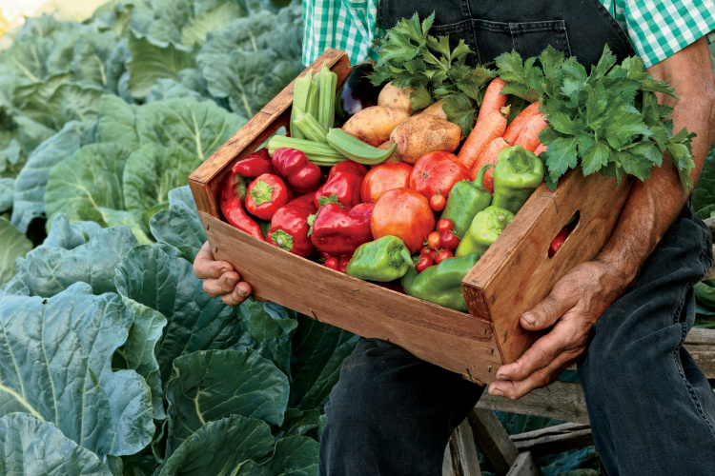

My wife has good training in the area of functional nutrition/medicine and wrote this excerpt below to another family member for the down and dirty on eating right see below.
We have to be very cautious as consumers to recognize label claims for health benefits on processed foods, which sprinkle minuscule, non-therapeutic amounts of healthful ingredients into otherwise poor-quality, high-calorie, nutrient-poor foods, giving us the illusion that we are doing something good for ourselves.
I encourage you to eat food that comes from a farmer’s field and not a food chemist’s laboratory — and you will not have to worry about all these functional food claims.
Here is what to eat:
Whole, real food such as vegetables, fruits, beans, nuts, seeds, whole grains, lean animal protein like small wild fish and poultry, and whole omega-3 eggs.
Small amounts of grass-fed, antibiotic- and hormone-free beef or lamb.
That is it.
Food scientists tend to make us think that we need all these special ingredients in foods to stay healthy.
But they are just extracting them from real, whole foods — so why not start with the whole food in the first place?

Bright guy who is an MD https://youtu.be/fKGJllgQGRI?si=6DfM8bJez4mmWBDM and had his eyes opened to functional medicine using mainly good old-fashioned food! This is worth your time regarding your health and the health of your family. FORGET political affiliations and just try hard to seek the truth through all the biased media we are exposed to on both sides.

This and exercise, even if just short walks, make a huge difference to your quality of life AND pocket book down the road!
Check these out when you have time, maybe on a road trip and throw Free Bird on in between for a break-HA!
https://youtu.be/xFU-78D-Vrg?si=l1m3Xl9AyBJfTeAW

https://youtu.be/19_1TDomYY8?si=7z8pknOXSwgJmBaw

Stay healthy!
Dave

